Dear all,

We will try to summarize the rationale that guided our analysis of the power statics of the data you collected on the first round.

First of all some (indulge me the repetition of notions that are known) basic concepts:

1) the effect size: the dimension of the effect (of the Deltamethrin) that we are looking for. That is the ratio between the mean values of 2 groups, of the variable we are studying (the lipid area) and the pooled variance of the groups of this variable we are studying (control/treated)

so basically the effect size is measured with this formula:

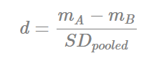

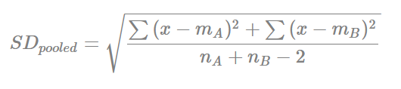

2) the alpha value: the p-value we are trying to achieve in our statistics

3) the power statiistics: this is the percentage of correctly refuse the null-hypothesis when this one is actually false.

Th number of samples can be inferred using these 3 values. So the idea should be: we hypothesize that we have a specific (or we expect) a specific effect size, and with that effect size we should expect statistical significativity below the alpha-value with that statistical power.

Now, we can fix the values of alpha and the power statistics (0.05 and 0.8).

The effect size can be calculated by the samples we get from the pivot study.

You will find attached to the mail the histogram of

1) Male, striatum, PND 30

2) Female, striatum, PND 30

1) Male, cortex, PND 30

2) Female, cortex, PND30

The histogram show on the horizontal axis the number of samples needed and in the vertical axis the number of lipids for which is is possible to see a significance effect for that number of samples.

I set a vertical line at 12 samples per group and the legend in the upper right corner shows the sum of lipids for which the effect is clear with that number of samples.

As you can see the with respect to 1000 lipids the number is small.

That could depend by a various number of factor.

And let's keep in mind that another good approach could be following the literature to understand the numerosity for class that have been used in other similar works.

